

<Name of Software Application>

CS 465 Project Software Design Document
Version 1.0
Megan Armstrong

Table of Contents

CS 465 Project Software Design Document 1
Table of Contents 2
Document Revision History 2
Instructions 2
Executive Summary 3
Design Constraints 3
System Architecture View 3
Component Diagram 3
Sequence Diagram 4
Class Diagram 4
API Endpoints 4
The User Interface 4

Document Revision History

Version | Date | Author | Comments
1.0 | <mm/dd/yy> | <Your Name> | <Brief description of changes in this revision>

Instructions

Fill in all bracketed information on page one (the cover page), in the Document Revision History table, and below each header. Under each header, remove the bracketed prompt and write your own paragraph response covering the indicated information.

Executive Summary

To deliver a highly scalable, stable, and secure digital platform for Travlr Getaways, the application utilizes a decoupled Model-View-Controller architecture built upon the unified MEAN stack. This full-stack JavaScript pipeline ensures that data transitions seamlessly from the cloud-based data repository directly to the user’s web browser, maximizing processing performance, reducing server strain, and allowing for fast updates to package listings. The software ecosystem is split into two distinct, interconnected interfaces to satisfy contrasting operational requirements. The customer-facing frontend operates on server-side rendering powered by the Express framework and the Handlebars template engine dynamically compiles lightweight HTML pages filled with live travel package listings, ensuring maximum search engine visibility and immediate initial load times. Conversely, the administrator portal operates as a client-side Angular single-page application designed for internal workflows, communicating asynchronously with an underlying RESTful API to allow administrators to perform secure creation, retrieval, modification, and deletion tasks on itinerary data without triggering full page updates.

Design Constraints

Building the web-based Travlr Getaways application involves several technical and architectural boundaries that define development guardrails and establish structural trade-offs throughout the development lifecycle. The mandate to develop exclusively within the MEAN stack dictates that the entire codebase across the database layers, routing rules, and user interfaces must use JavaScript or TypeScript. While this modernizes development and prevents language fragmentation, it creates a boundary that restricts the engineering team from integrating legacy backend libraries or tools written in alternative environments like Python, Java, or PHP. Maintaining two distinct architectural frontends introduces a separation of concerns that requires careful maintenance. Because the public customer-facing interface relies on server-rendered layouts and the secure admin system runs as a client-side rendered application, developers must build and maintain comprehensive API documentation to ensure that identical data objects map uniformly across both environments. Utilizing MongoDB as the persistent storage layer introduces structural boundaries since it is an inherently non-relational, document-oriented database. Complex relational schemas outlined in client wireframes, such as linking specific customer accommodations or regional excursion excursions directly to general travel packages, cannot rely on native database joints and must instead be handled explicitly via application-level object referencing or embedded sub-document structures. Because the public, customer-facing portion of the web application functions using stateless server-rendered requests, tracking live user actions across different pages presents a technical boundary. Unlike client-side frameworks that hold active memory in a global state, this architecture must use explicit session tokens, localized database lookups, or cookie configurations to preserve user preferences or trip filtering histories across routing states.

System Architecture View

Component Diagram

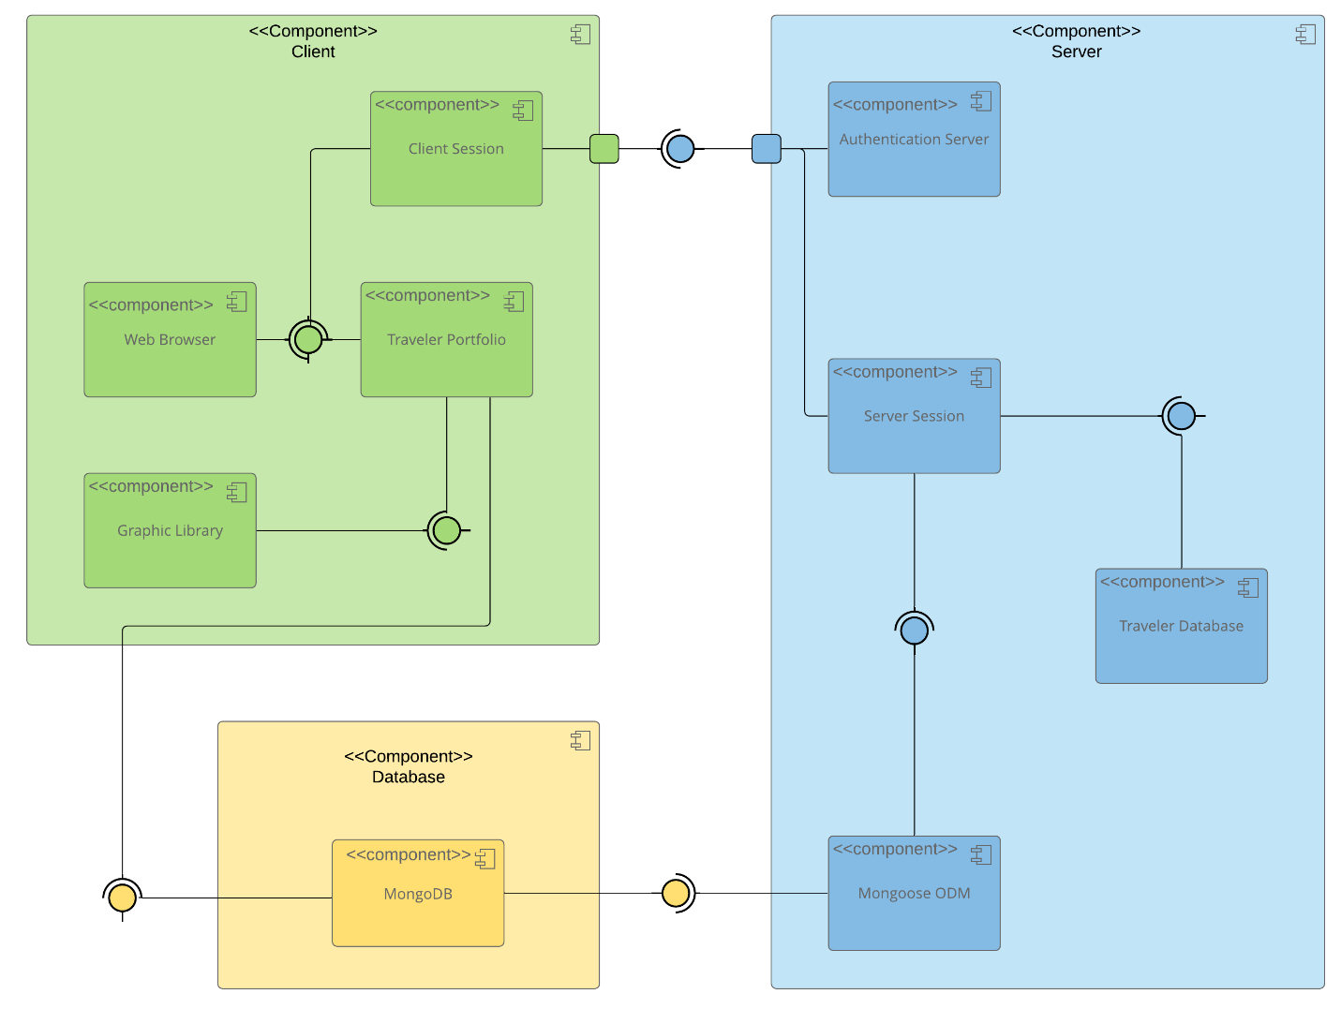

A text version of the component diagram is available: CS 465 Full Stack Component Diagram Text Version.

The structural architecture of the Travlr Getaways full-stack application utilizes a multi-tiered environment that strictly isolates presentation logic, network control flow, and persistent data storage. Data requests flow downward from user-facing screens into an application processing layer, which validates permissions and makes transactional requests to the underlying database engine before formatting and returning information to the user. The presentation tier functions as the primary collection point for user interactions and is split by target audience. The public consumer browser requests pre-compiled web documents directly from the application engine, whereas the administrative dashboard pulls an independent bundle that executes application processes directly within the browser, making narrow data calls only when transforming back-end records. The Express application and Node runtime environment act as the centralized traffic control mechanism for the entire software suite. This component intercepts inbound browser traffic via explicitly mapped RESTful API endpoints, determines whether a request demands server-side layout compilation or asynchronous data serialization, communicates with the data adapters, and manages security policies. The foundational database component relies on MongoDB to house raw enterprise assets securely within unstructured collections. It uses a Mongoose abstraction layer to bind schemas to data inputs, providing structure to non-relational files and validating data properties before formatting records into uniform JSON sets for delivery back up to the routing and presentation systems.

Sequence Diagram

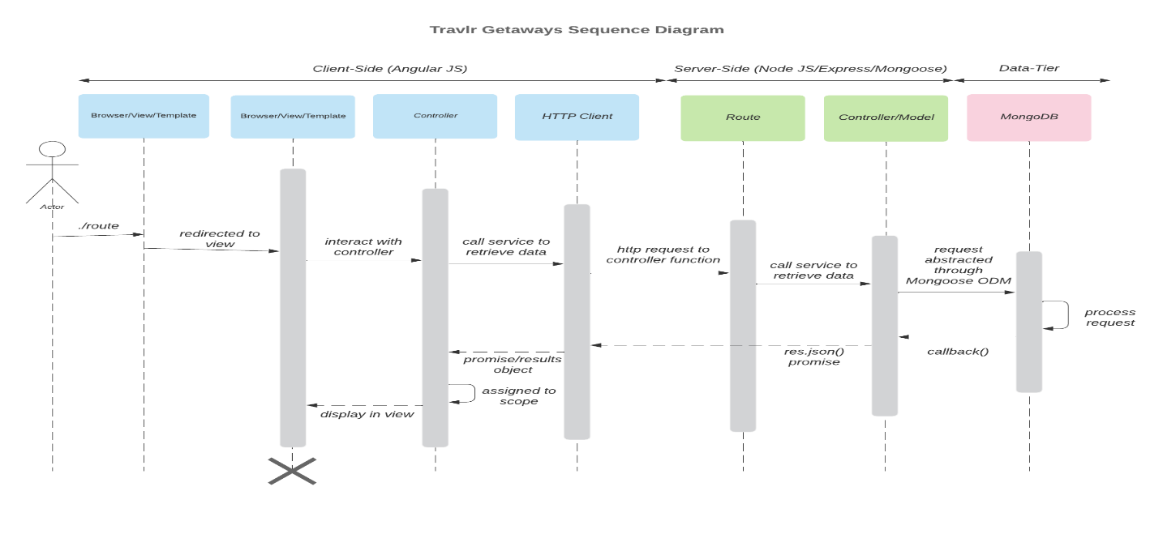

System Architecture Flow Narrative

The full-stack architecture of the Travlr Getaways application enforces a strict Separation of Concerns across three major tiers: Client-Side (Angular JS), Server-Side (Node JS/Express/Mongoose), and Data-Tier (MongoDB).

The request-response lifecycle functions as follows:
1. Routing and View Initialization: An Actor navigates via an initial route, causing the Browser/View/Template layer to initialize and redirect the user to the active application layout.
2. Client-Side Orchestration: User interactions on the frontend layout pass functional instructions downstream to interact with the client-side Angular Controller.
3. Network Data Requests: To pull real-time database documents without forcing a full page reload, the Angular Controller tells the HTTP Client to dispatch an asynchronous network request.
4. Server Routing Gateway: The inbound network transaction travels across the network boundary, hitting the backend Express Route layer. This route acts as a traffic controller, catching the "/api" endpoint string and mapping it to the server logic.
5. Abstracted Controller/Model Layer: The request flows directly into the unified server-side Controller/Model layer. This layer utilizes Mongoose ODM functionality to execute a data retrieval query against the database using JavaScript methods rather than raw database commands.
6. Persistent Storage and Resolution: The query reaches MongoDB, which processes the request. MongoDB fires a callback() streaming the document records back to the Mongoose Controller/Model layer. The server-side layer builds a res.json() promise response containing the data. This JSON payload flows back to the client-side HTTP Client, resolves into a promise/results object, assigns it to the component scope, and displays the populated trip entries in the final frontend Browser/View/Template layout.

Class Diagram

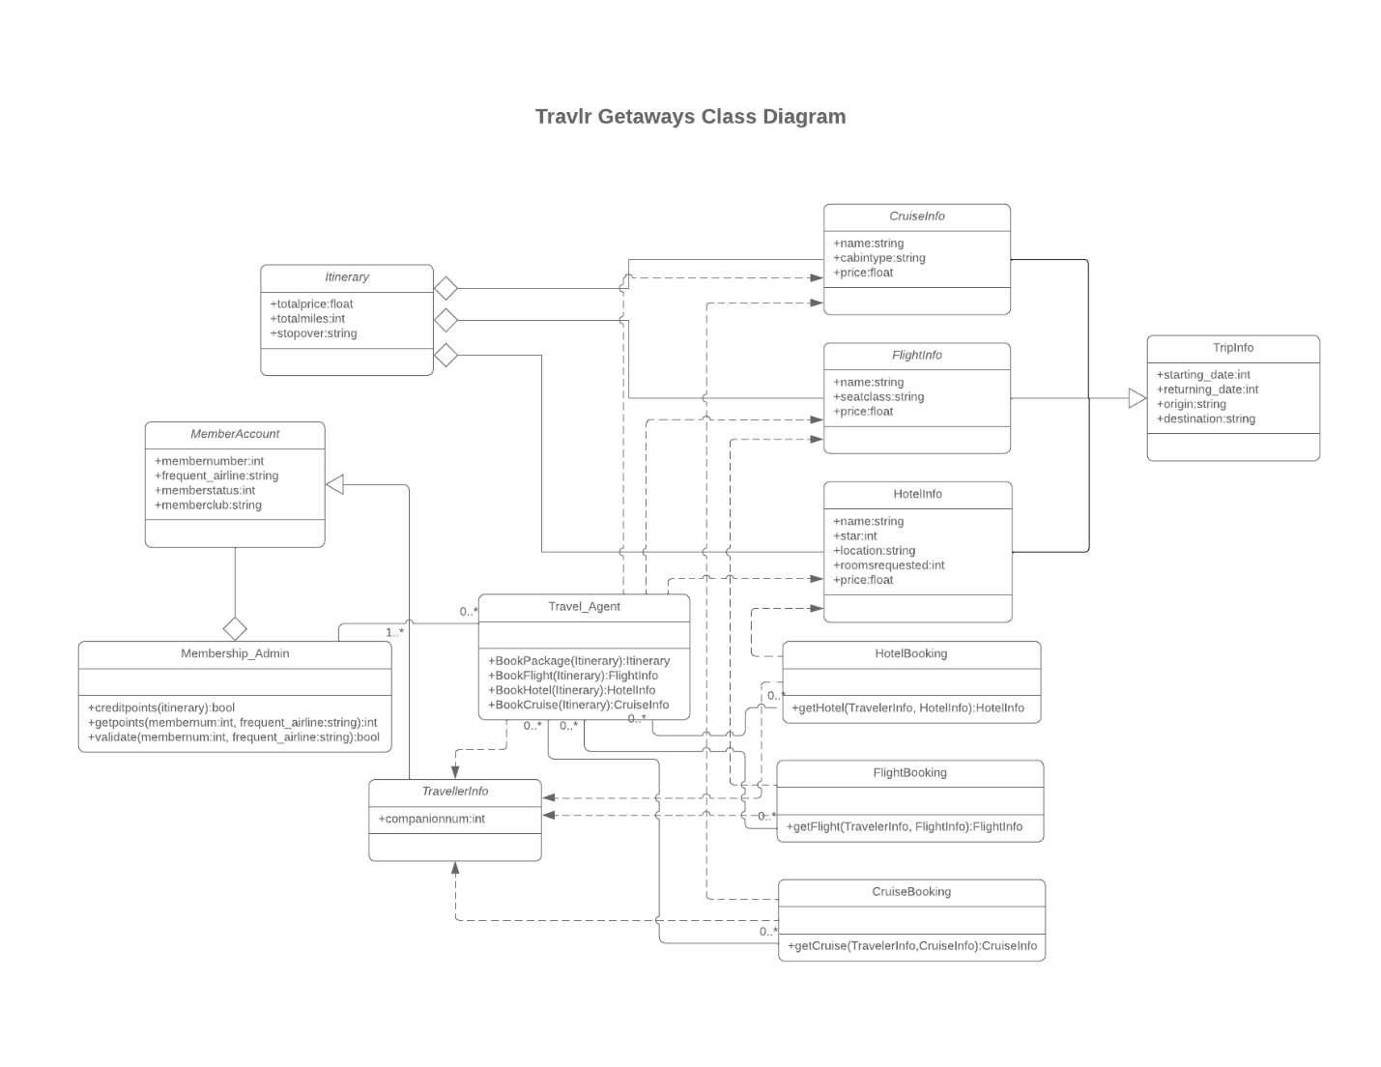

Class Diagram Architecture Narrative

The structural architecture of the Travlr Getaways system utilizes an object-oriented paradigm implemented via JavaScript classes to model real-world travel components and booking workflows. The system is split into four cohesive domains: Account Management, Component Specification, Aggregation Models, and Fulfillers.

1. Account Management and Infrastructure
- MemberAccount: Encapsulates user profile details including tracking codes, frequent flyer numbers, and tier status settings.
- Membership_Admin: Functions as an infrastructure controller to validate accounts, verify credentials, and process loyalty rewards points.
- TravellerInfo: Manages basic demographics and traveler details, including companion counts, used during booking processing.

2. Travel Component Specifications (Inheritance Tree)
- TripInfo: Serves as the abstract base parent class, enforcing a unified structure for dates, origin locations, and destinations across all travel options.
- FlightInfo: Inherits from TripInfo, extending it with flight-specific details like airline seat configurations and seat classes.
- HotelInfo: Inherits from TripInfo, adding room counts, ratings, and physical locations.
- CruiseInfo: Inherits from TripInfo, tracking cruise line names, stateroom tiers, and vessel cabin types.

3. Aggregation and Orchestration
- Itinerary: Acts as a composite container that aggregates distinct instances of FlightInfo, HotelInfo, and CruiseInfo to compute combined pricing and travel metrics.
- Travel_Agent: Serves as the primary system coordinator, orchestrating complex workflows to book individual components or package multi-tier options.

4. Operational Fulfillers
- FlightBooking, HotelBooking, and CruiseBooking: These interface engines serve as specialized factories. They process inputs from TravellerInfo and component parameters to cleanly return completed reservation receipts.

API Endpoints

<Exposing RESTful endpoints is a design approach to enable an application to participate in a larger ecosystem. Document each endpoint in the table below, including the HTTP method, purpose, URL, and notes.>

Method | Purpose | URL | Notes
POST | <CREATE A NEW THING> | </api/things> | <CREATES A NEW THING INSTANCE USING THE DATA PROVIDED IN THE REQUEST BODY.>
PUT | <UPDATE A THING> | </api/things/:thingId> | <REPLACES AN EXISTING THING INSTANCE OR CREATES IT IF IT DOESN’T EXIST, USING THE REQUEST BODY. >

The User Interface

<Insert screenshots from the development of the SPA development to show the following: (1) a unique trip, added by you, (2) the Edit screen, and (3) the Update screen.>

<Summarize the Angular project structure and how it compares to the Express project structure. Be sure to describe the rich functionality provided by the SPA compared to a simple web application interaction. Describe the process of testing to make sure the SPA is working with the API to GET and PUT data in the database.>

